ACKLEY FUNCTION

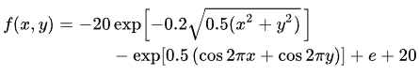

Best Solution: [-1.61391014 -7.97875332]

Best Value: 15.267744148600805

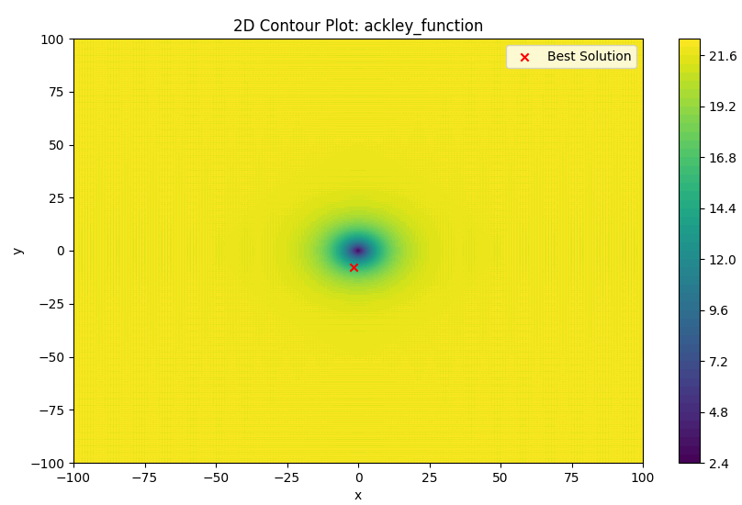

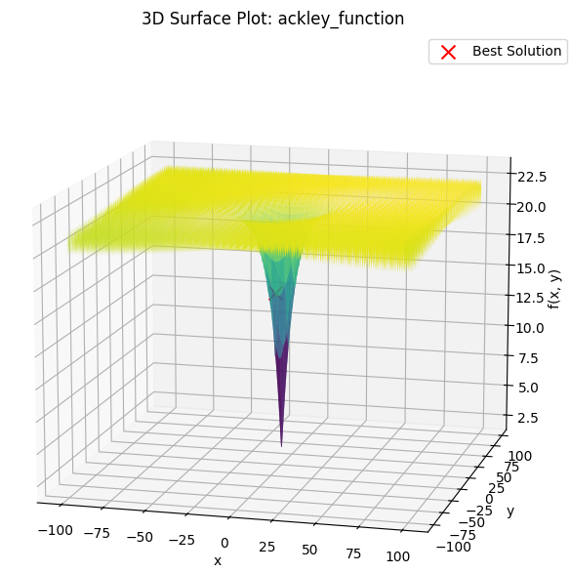

Rastrigin FUNCTION



Best Solution: [14.45896631 -3.54019899]

Best Value: 260.94690561070746

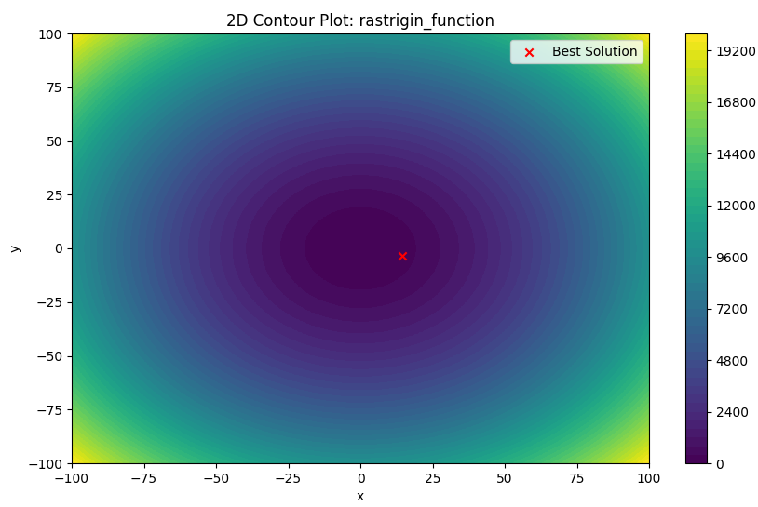

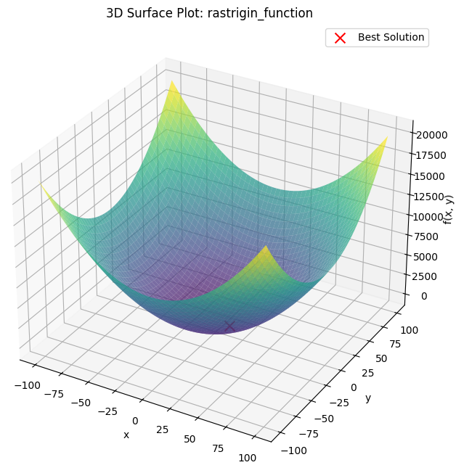

Rosenbrock Function



Best Solution: [11.63927217 88.41616773]

Best Value: 221544.5100245819

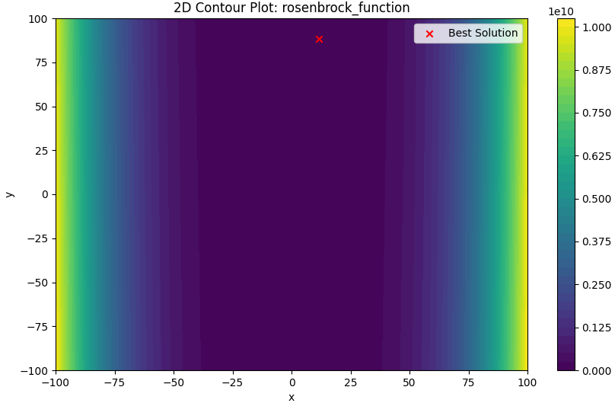

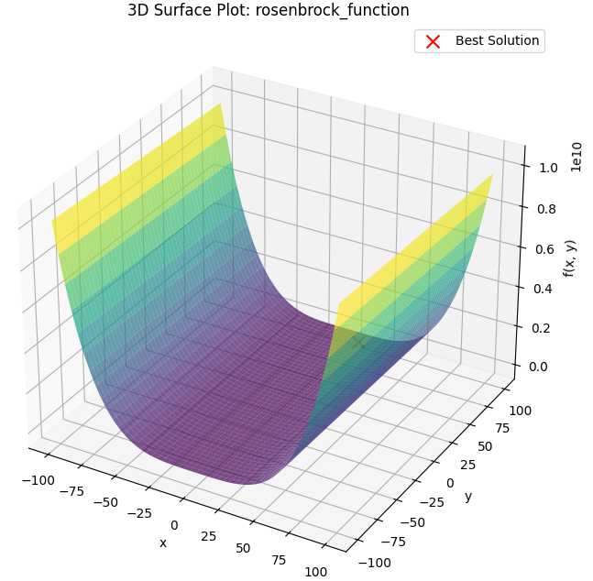

Griewank Function

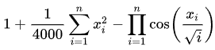

Best Solution: [-12.22985343 26.53658234]

Best Value: 0.2729660804174685

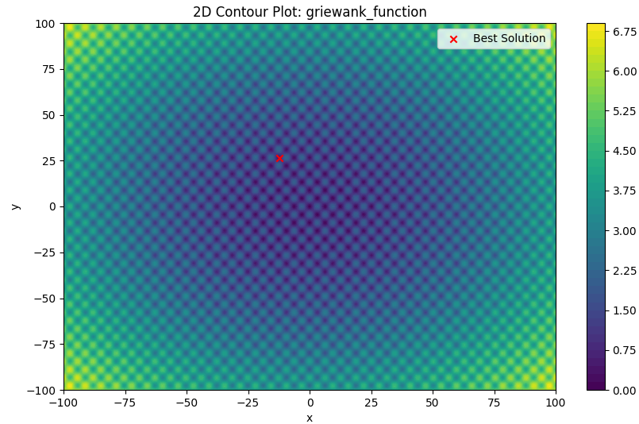

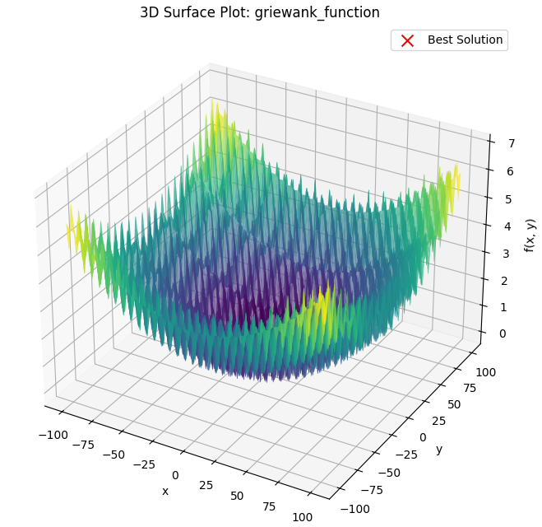

Schwefel Function

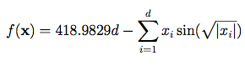

Best Solution: [54.46470822 69.42304082]

Best Value: 727.8651453669843

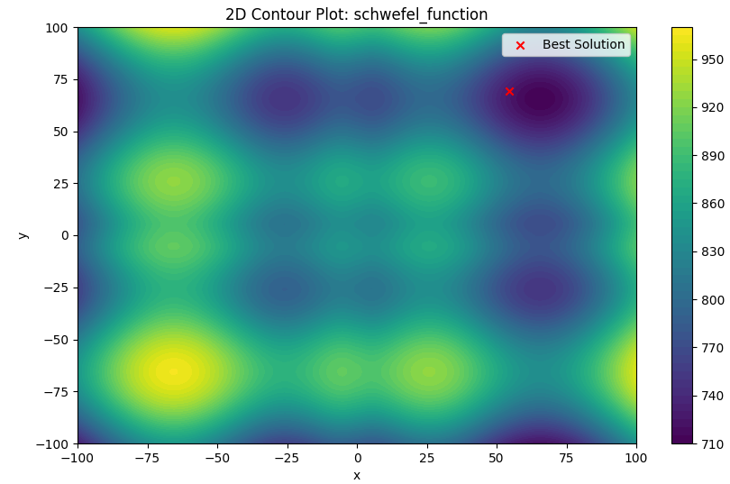

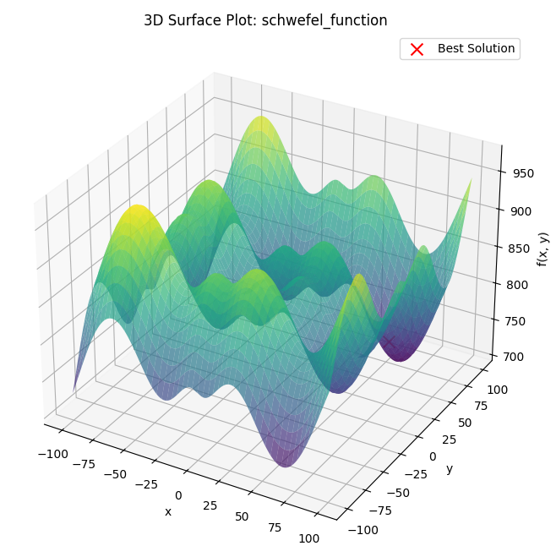

Sphere Function

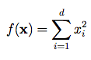

Best Solution: [ 9.97590373 -14.3056945 ]

Best Value: 217.13057373859215

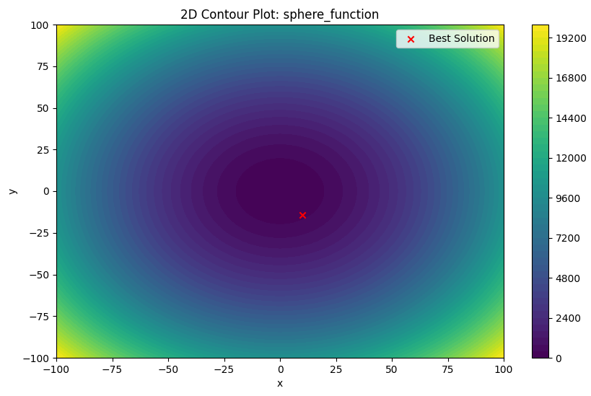

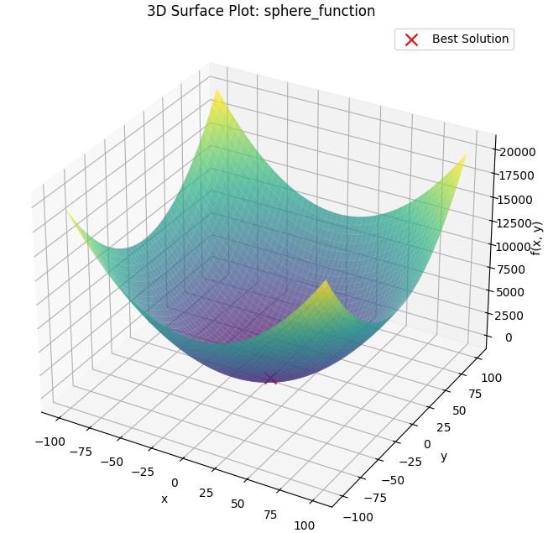

Levy Function

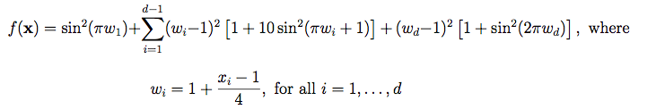

Best Solution: [ 7.71738644 -6.5086629 ]

Best Value: 8.77416151556682

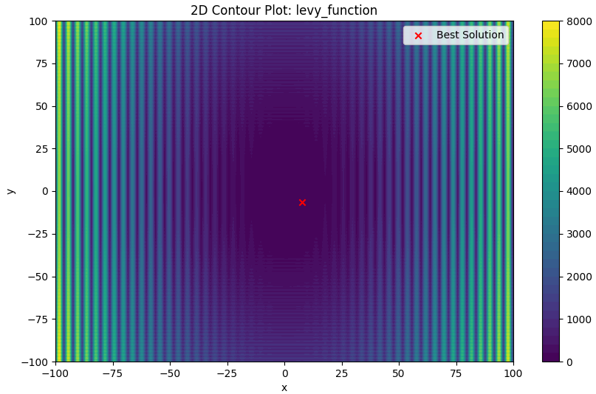

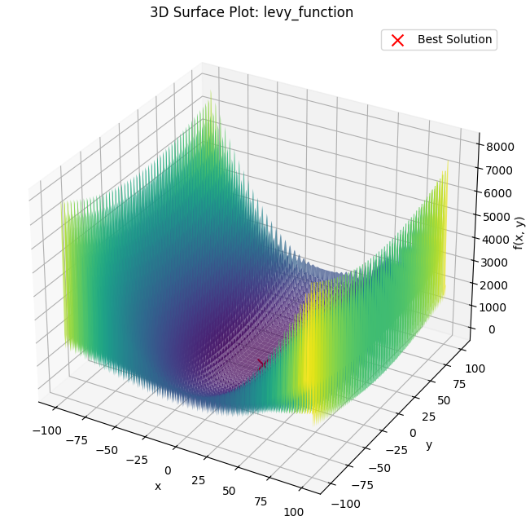

Beale Function



Best Solution: [100 0.38893169]

Best Value: 18750.30348157828

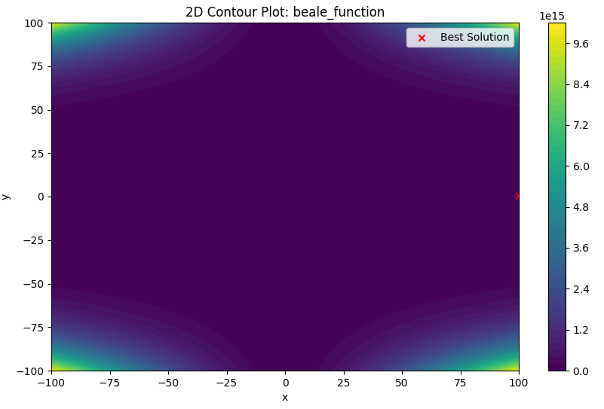

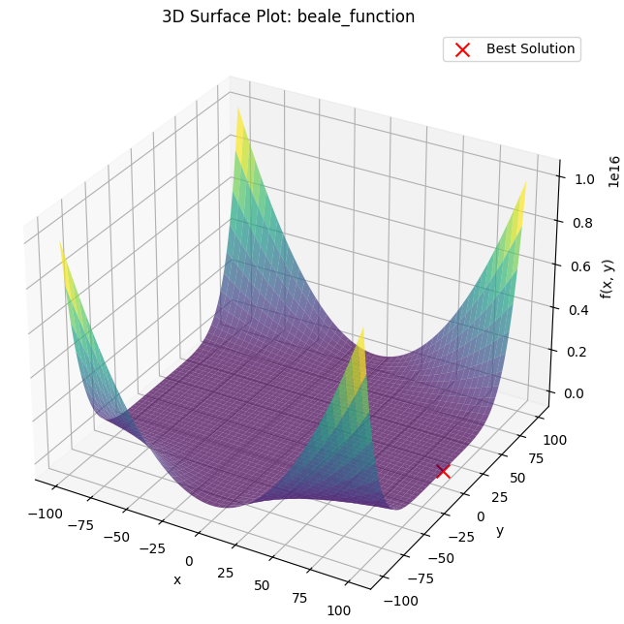

Booth Function



Best Solution: [ 20.93054271 -34.16784648]

Best Value: 2967.1739101552316

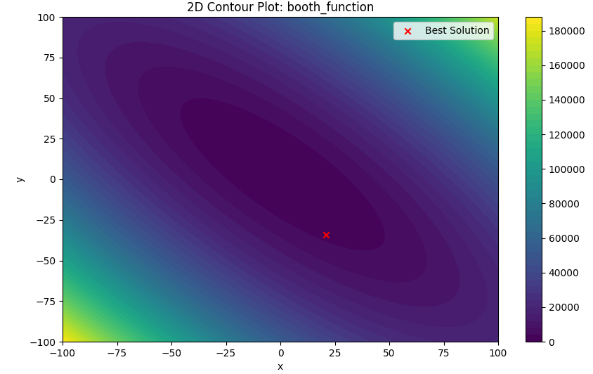

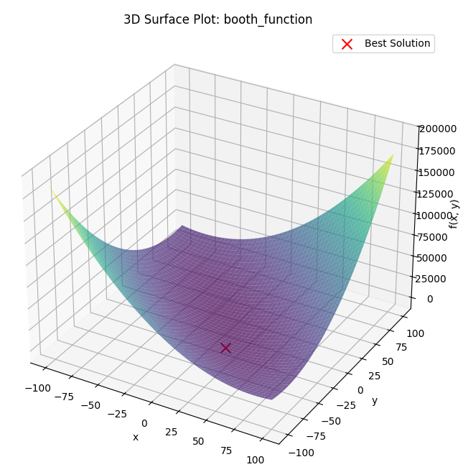

Easom Function



Best Solution: [-4.89221163 -6.49210949]

Best Value: -8.065241156970764e-70

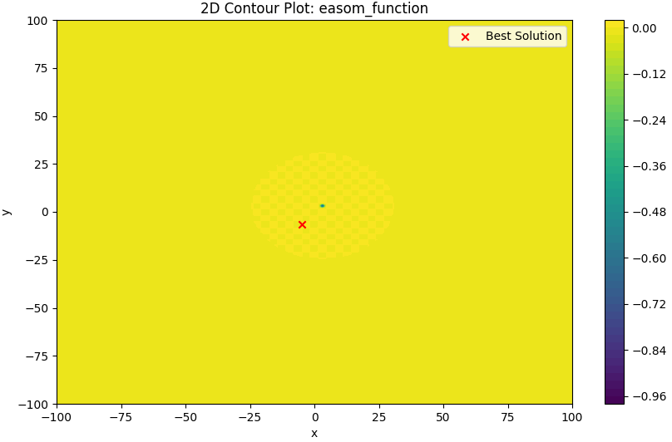

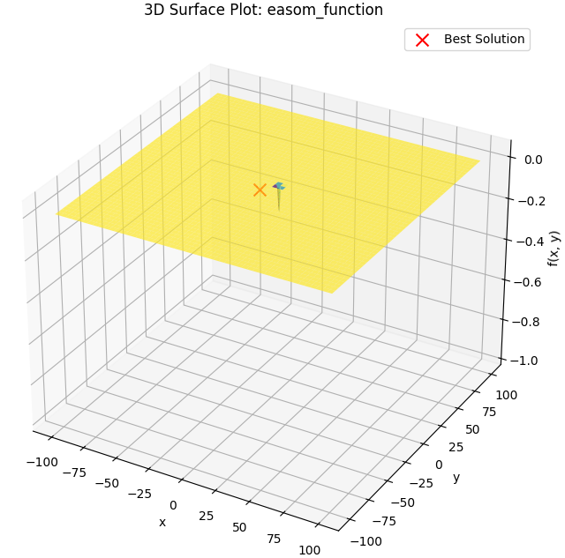

Michalewicz Function

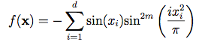

Best Solution: [ 19.97375517 -100]

Best Value: -0.7764574059398142

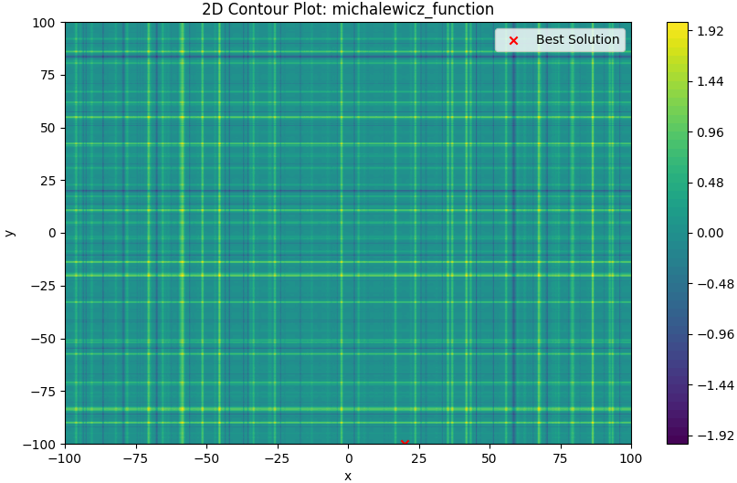

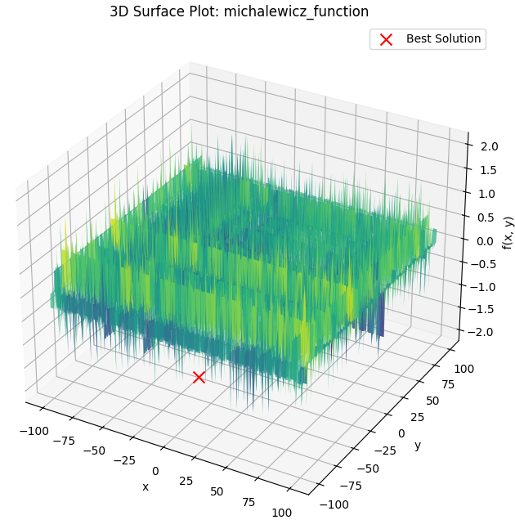

Zakharov Function

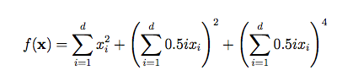

Best Solution: [ 51.86824984 -27.24543573]

Best Value: 3437.3054494549297

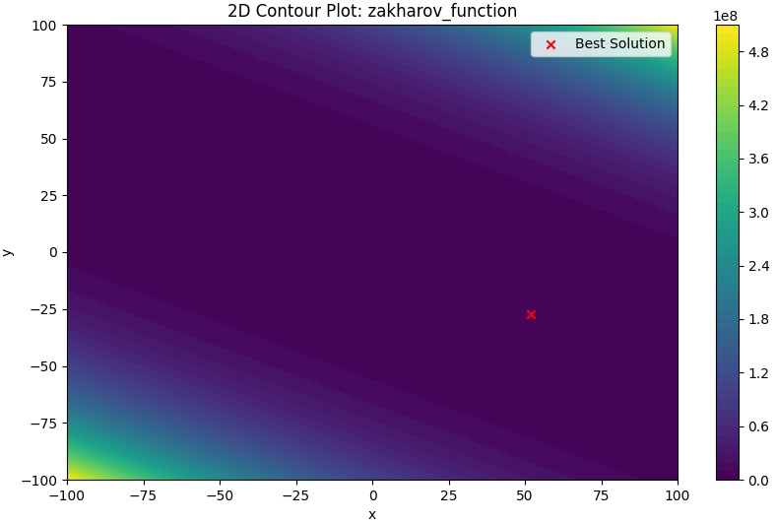

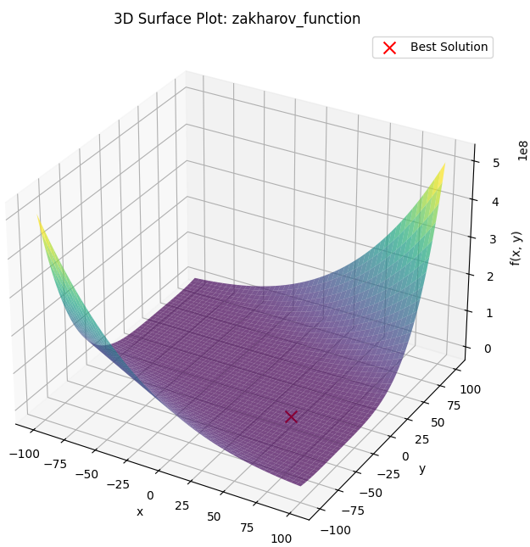

Sum of Different Powers Function

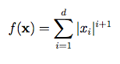

Best Solution: [-23.99138899 1.18024345]

Best Value: 577.2307949410633

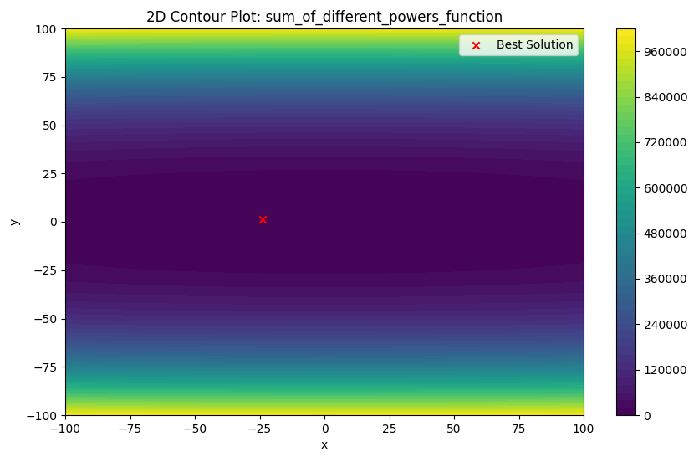

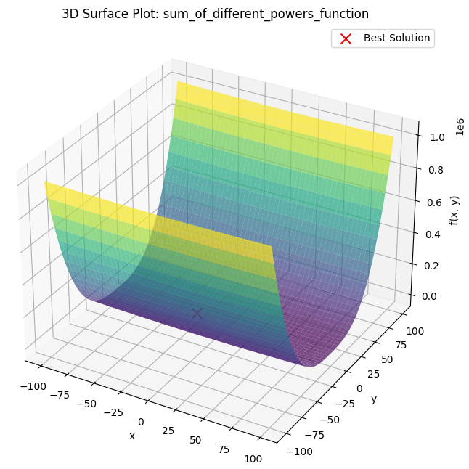

Three-Hump Camel Function



Best Solution: [0.03216035 1.25172646]

Best Value: 1.6091425472282752

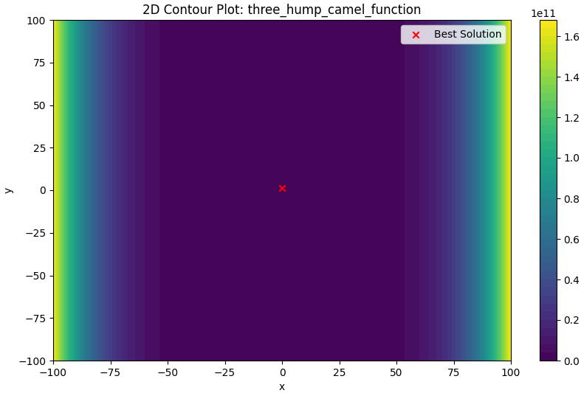

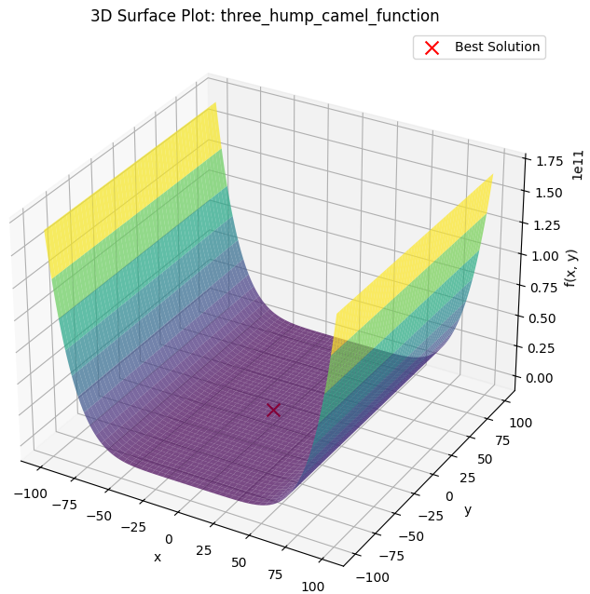

Xin-She Yang Function



Best Solution: [-15.92800396 -24.42901163]

Best Value: 35.65343634033759

